***What is jQuery***

**jQuery:**

The JS library that will prevent our figures from breaking.

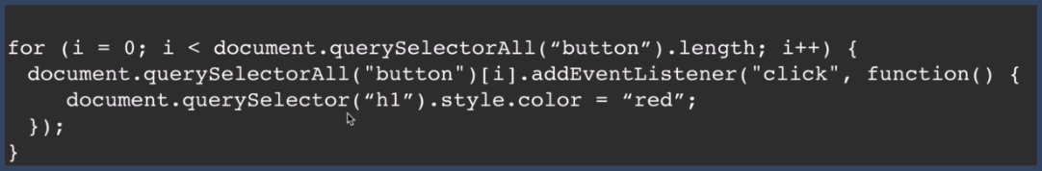

**John Resig** found jQuery to do same thing as above code with small code lines like below.



This code will work same as above.





If you want to be shorter than simply right $ sign.



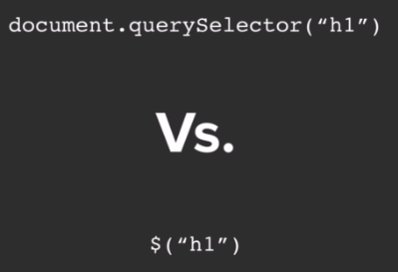

Both queries are same in functionality.